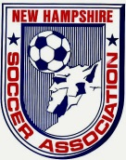
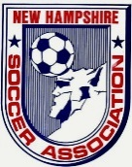
New Hampshire Soccer Association
Board Meeting Minutes for 01-13-15

Attendees: Bob Willey, Cory Halvorsen, Tom Haydock, Diane Hebert, Mark Chagnon, Bill Thornton, John Ferreira, Ric Marion, Mark Sadler, Dave Bruno, Craig Jensen, Greg Brehio, & Carla Nastri

Meeting called to order at 6:20

Secretary Report: Written Report attached. Tom Haydock made a motion to accept the minutes. Diane Hebert seconded the motion. Minutes Accepted

Treasurers Report: Written report attached. Carla Nastri made a motion to submit to audit. Mark Chagnon seconded the motion. Reports accepted.

Executive VP: Written report attached.

Recreation VP: No report attached.

Competitive VP: No written report attached..

Adult VP: Written report attached.

Indoor VP: Written report attached. There is a website for our sanctioned indoor facilities. Craig Jensen made a suggestion of a resolution to be voted on that all communication on our website regarding soccer be positive,.

TOPSoccer: No written report.

President’s Report: No written report.

State Coach of Education: Written report attached

State Coach of ODP: Written report attached.

State Referee: Committee: Written report attached.

State Administrator: Written report attached.

State Registrar: Written report attached.

Risk Management: Written report attached.

Ongoing Business:

Adult Leagues. Cory Halvorsen and Mark Chagnon will meet to come up with a plan.
AGM: Plans are on track. Need to finalize the schedule.

NHSL: Registration is still open. U16-U19 age groups are growing. LLC meeting is to be rescheduled the last week of February. There is one open position on the LLC.

Tri-state tournament: Bob communicated with Vermont and Maine that we would be interested in hosting the tournament on an ongoing basis.

State Cup and President’s Cup: Registration is still open.

Candidates for Board Position: candia campbell has declared for the president position, Dan Wyborney has declared for the position of VP Competitive. Mark Chagnon has declared for the position of VP Adult, John Ferreira has declared for the position of Treasurer. We should send to our members and put up on our website all resumes and write ups submitted by our candidates..

Survey: Eric will be sending a survey to the clubs and organizations that he holds clinics for to see if they are getting what they need out of the clinics.

Fields: Closing to happen in the near future. An agreement was reached with the seller regarding the back taxes.

New Business

NHSA Night at the Revolution: Has been scheduled for Saturday, May 16, 2015.

US Youth Soccer month will be scheduled for the last Sunday in September.

Good of the Game

Thank Dave Bruno for his service to soccer in NHSA
Thank Bob Willey for his service as president of NHSA

Next Board Meeting: Tuesday, February 10th.

Meeting adjourned at 8:45PM>

Respectfully Submitted,
Carla Nastri
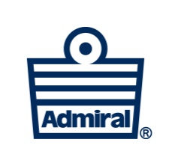
NHSA Secretary

